Command and Control:
In the command and control the attacker achieved the persistence through establishing a connection with the victim’s machine.
The attackers blend the malicious traffic with the port 80 Http and the port https 443 to bypass the firewalls in this way the malicious traffic becomes the part of legitimate traffic.
DNS the victims machine makes frequent request to the attacker DNS server to make the connection with it this is called the DNS tunneling.

8) Actions on Objectives (Exfiltration’s):
If the attacker successfully achieved this success. Now it’s time to achieve its goals.
Following are the activities that an attacker can perform on this stage like:
- Gaining internal Credentials from the users.
- Perform Privilege escalations (i.e. gaining the root access or the network administrator access by exploiting the internal vulnerabilities.
- Internal reconnaissance (for example, an attacker gets to interact with the internal software to find vulnerabilities.
- Delete the backup or shadow copy. The shadow copy is a Microsoft technique in which the backup is created and regular snapshots and volumes are created.
- Lateral Movement through company company’s environment.
- Overwrite or corrupt data.

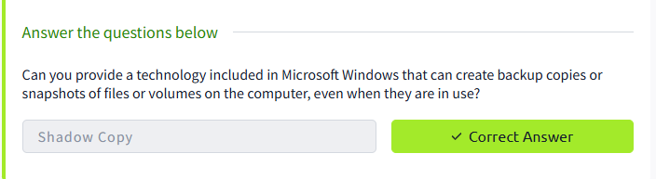

Practice Analysis:

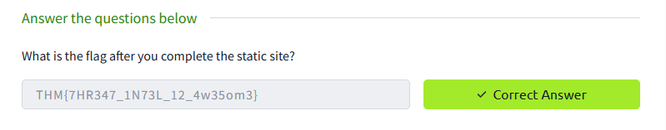

10 Conclusion:

The cyber kills chain is considered as a traditional kill chain and was not modified or updated since 2011. And it does not provide the strategy about the insider threat:

The insider threat is a threat in which the legitimate user could harm the organizations under some influence or personal preference.
It does not cover all the TTP now the adversaries developed these tactics, techniques and procedure. They can slightly modify the file hashes and Ip address to deceive the system. We need AI based detection system that detects these changes.
